***A Mini Project Synopsis on***

**Helpdesk for students**

**S.E. - I.T Engineering**

**Submitted By**

**Soham Dalvi 21104010**

**Yuvraj Gage 21104019**

**Sumit Gussain 21104022**

**Under The Guidance Of**

**Prof. Sonal Balpande**



**DEPARTMENT OF INFORMATION TECHNOLOGY**

A.P. SHAH INSTITUTE OF TECHNOLOGY

G.B. Road, Kasarvadavali, Thane (W), Mumbai-400615

UNIVERSITY OF MUMBAI

**Academic year: 2022-23**

**CERTIFICATE**

This to certify that the Mini Project report on Student Helpdesk has been submitted by Sumit__Gusain(21104022), Soham__Dalvi(21104010) and Yuvraj Gage (21104019) who are a Bonafede students of A. P. Shah Institute of Technology, Thane, Mumbai, as a partial fulfilment of the requirement for the degree in **Information Technology**, during the academic year **2022-2023** in the satisfactory manner as per the curriculum laid down by University of Mumbai.

Ms. Sonal Balpande

Guide

Dr. Kiran Deshpande Dr. UttamD.Kolekar

Head Department of Information Technology Principal

External Examiner(s)

1.

2.

Place:A.P.Shah Institute of Technology, Thane

Date:

**ACKNOWLEDGEMENT**

This project would not have come to fruition without the invaluable help of our guide **Sonal Balpande.** Expressing gratitude towards our HoD, **Dr. Kiran Deshpande**, and the Department of Information Technology for providing us with the opportunity as well as the support required to pursue this project. We would also like to thank our teacher Ms. RujataChaudhari who gave us her valuable suggestions and ideas when we were in need of them. We would also like to thank our peers for their helpful suggestions.

**TABLE OF CONTENTS**

1. Introduction.......................................................................................................... 1
   1. Purpose........................................................................................................... 1
   2. Objectives....................................................................................................... 1
   3. Scope.............................................................................................................. 1
2. Problem Definition…………………................................................................... 2
3. Proposed System………....................................................................................... 3
   1. Features and Functionality……………………………………………...…...3
4. Project Outcomes.................................................................................................. 4
5. Software Requirements ........................................................................................ 5
6. Project Design........................................................................................................6
7. Project Scheduling……………………………………………………………….10
8. Conclusion………..................................................................................................15
9. Refences ………………………………………………………………………….16

**CHAPTER 1**

**Introduction**

Our project is about helpdesk for students . Students can search for their queries and get answers to those questions. Saves time of students and faculty . Students can get all information about their faculty and teachers can also get to know about the queries asked by students and can also answer those questions . Once the answers are given they will be saved in database and can be retrivedwhen searched by students.

* 1. **Purpose :**

Our project is a helpdesk for students. Basically students can get answer to their questions , the answer will be already stored in the database. If the question is not there in database then student can add his/her question which will be answered by teachers / faculty. All this will be provided by GUI .

* 1. **Objectives :**
* Write objectives of selected project topic in numbers like
* 1.To build a more userfriendly environment
* 2. To reduce work load on faculty
* 3.To give quick answers
  1. **Scope:**
* Can be applied to moodle to enhance its user friendliness
* Can be useful to visitors by placing an human resource tab
* Can be used to collect data from students and make

**CHAPTER 2**

**Problem Definition**

This project will help the faculties. Sometimes faculties have to repeat the instructions. As once the question is answered by the teacher students don’t have to ask teacher again and again. Its also reduces the communication gap between teachers and students.

**CHAPTER 3**

**Proposed System**

Features and functionalities of our project:

* Human resource info based on users UID
* Dynamic memory that can be changed by administrator
* Frequently asked question sorted in descending order in GUI
* A search column that will search questions

**CHAPTER 4**

**Project Outcomes**

* User Can log in
* User can search for questions available
* User can click on answers to the questions if required question is found
* User can send query to the administrator if their questions are not found
* Admin can add new students to the database.

**CHAPTER 5**

**Software Requirements**

* MySQL
* Java

**Operating System**

* + Microsoft Windows 11

**CHAPTER 6**

**Project Design:**

**Block Diagram-**

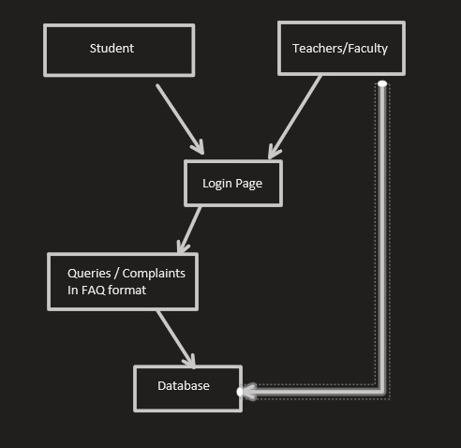

**Student page-**

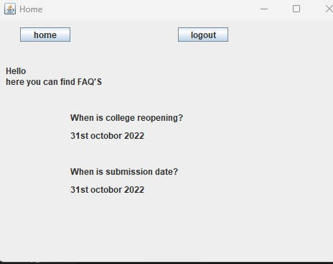

**Login Page -**

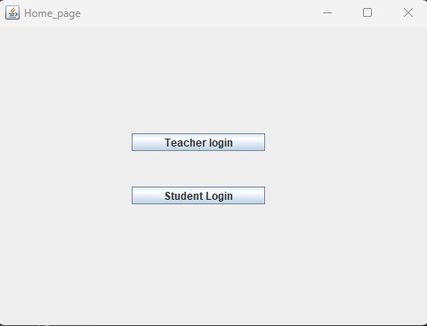

**Teacher login page-**

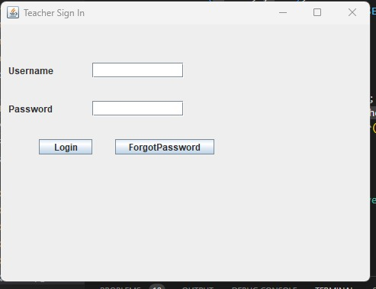

**Teacher home page**

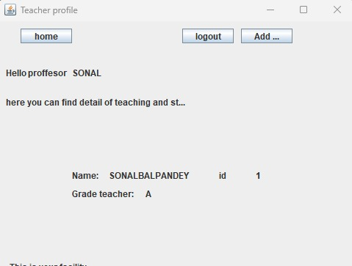

**Student login page -**

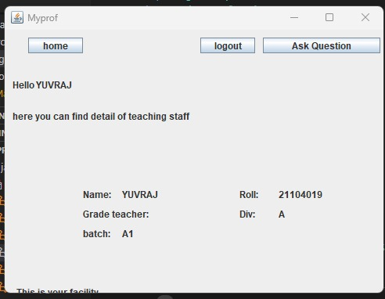

**Query search page-**

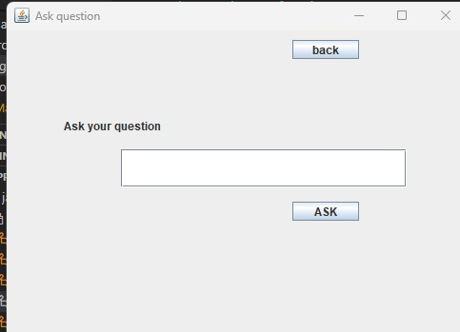

**CHAPTER 7**

**Project Schedule:**

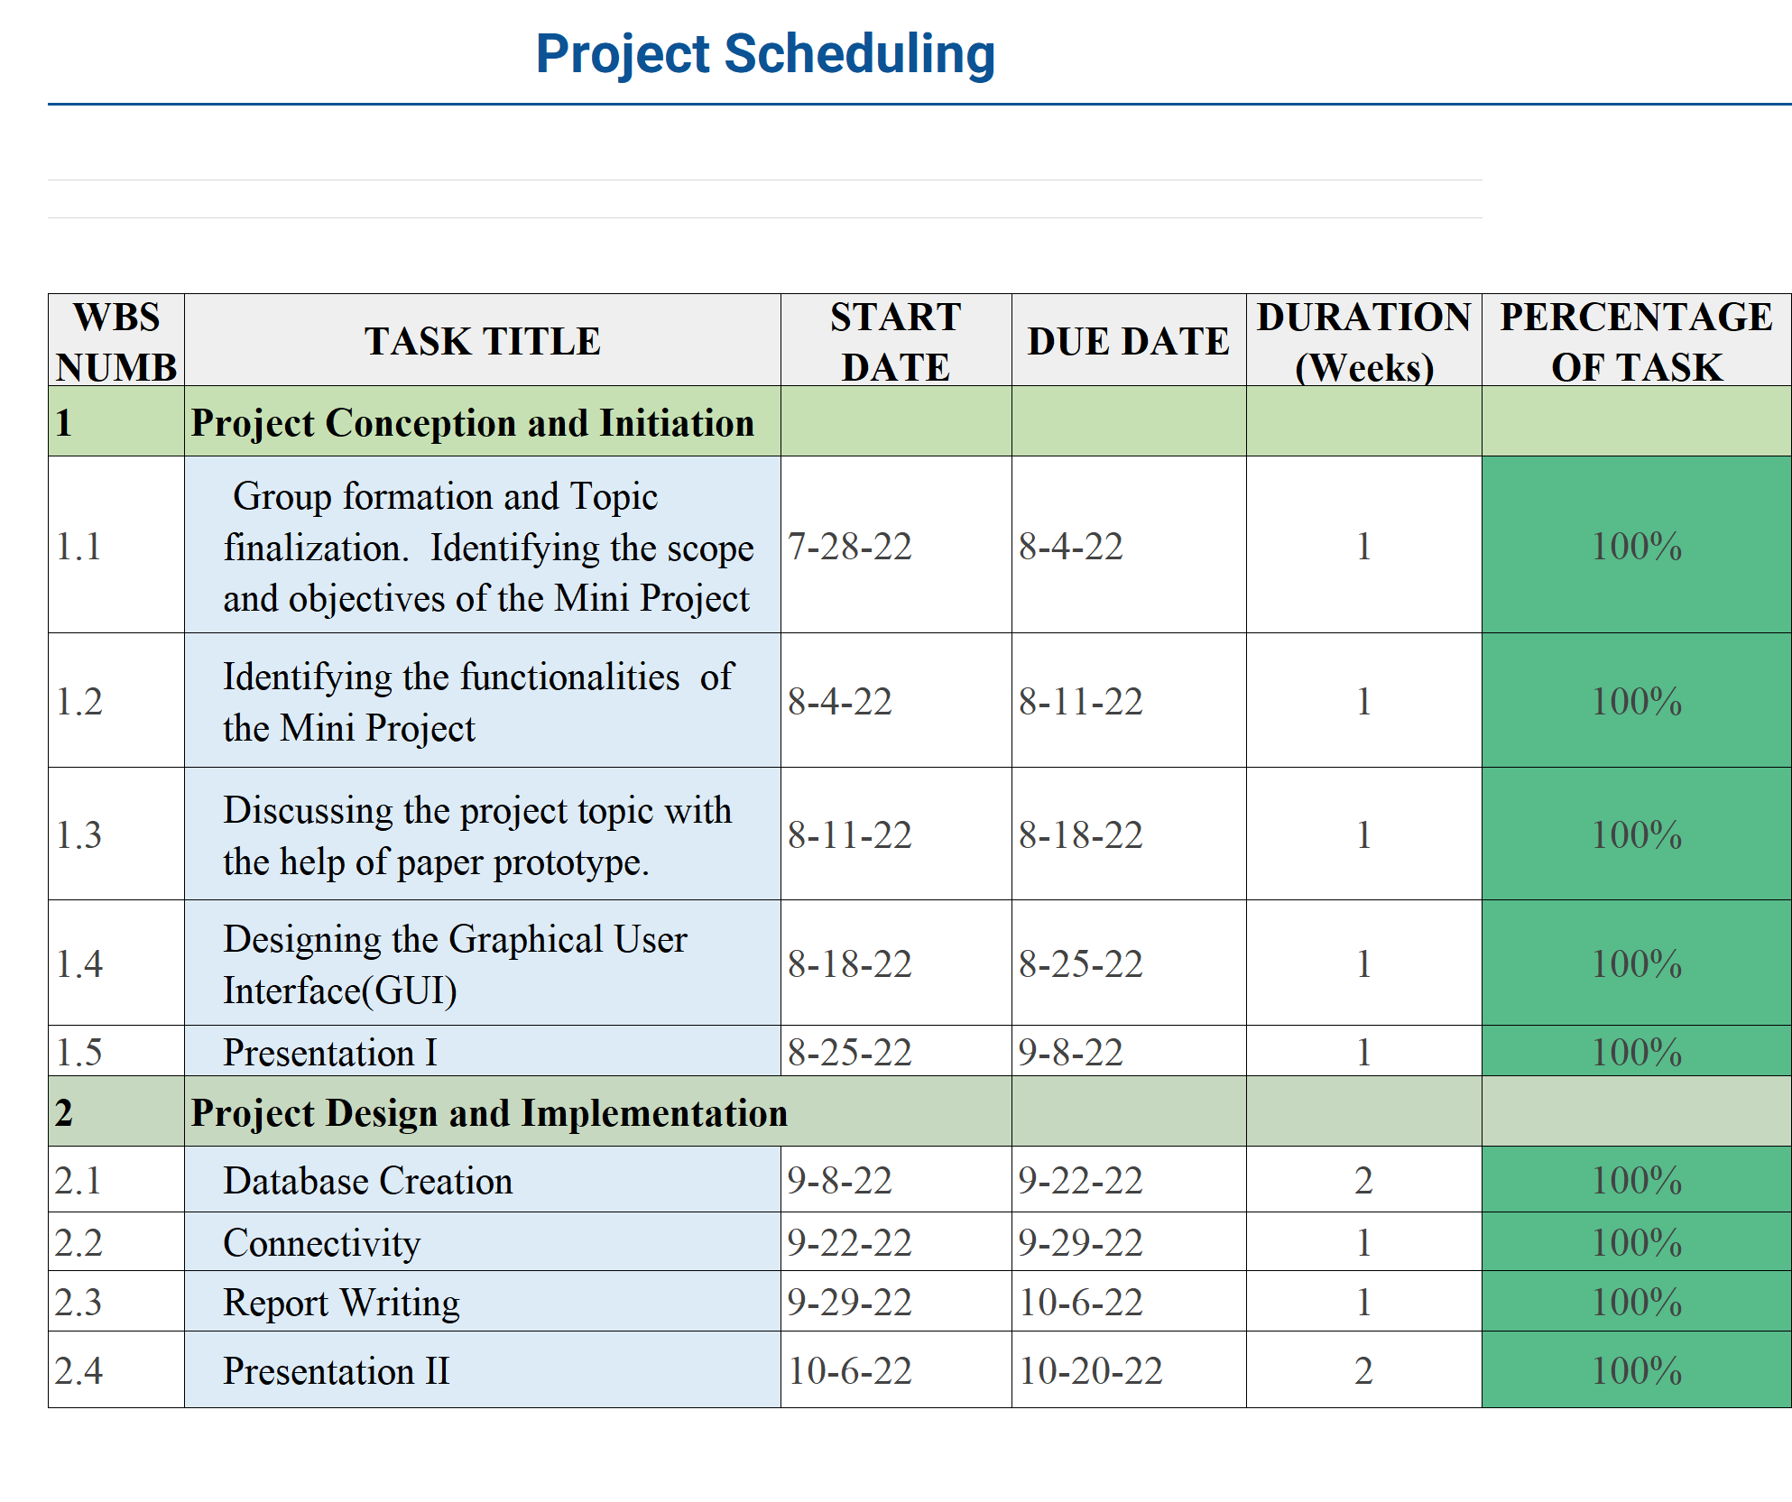

**CHAPTER 8**

**Conclusion:**

Hence we have found the solution to minimize the communication gap between

Students and teachers and to solve the problems faced by students and quicker and more efficiently with .We also learned java , database connectivity with java and how the connectivity works with database.

**Chapter 9**

**References**

[1] w3schools.com

[2]Youtube - FreeCodeCamp, Code with Harry